Documentation of Einstein Changes in Colorcon:

**Licensing Conversation 1/22/2021** **1**

**How to handle next app** **2**

B2BMA: 2

Pardot Engagement 2

**What was done for the end of 2020 app upgrade:** **4**

**Colorcon Einstein Details** **7**

Applications (5) 7

Dataflows (4) : 8

Recipies 9

Pictures of changes made: 9

Default Salesforce Dataflow - completely new flow 9

SA Test Recipe 10

# Licensing Conversation 1/22/2021

Misha Zeineddine - salesforce

Kyle Shaughnessy - salesforce dashboards

Adriane Niedziela - colorcon IT team

Diana Samuel - colorcon our main contact

Saurabh Agarwal - colorcon technical dashboard and bi

Jim Cassella - colorcon manager - marketing knowledge

Deborah - colorcon manager

One sales cloud license - enterprise to have this

Einstein Analytics growth - 21 user - for everyone with a login

* Can get 30 minutes of 1-1 consulting
* Academies - 2 hour skill classes
* Can pull from oracle directly if they need it now
* Not Pro
  + Not predictive capabilities for more AI and machine learning
  + Data volume - 200 million row limit (contractual ) not 2 billion
  + Concurrent data flow

Essential - professional - enterprise

They are moving from professional to enterprise

SAML - (one login) - pardot users need lightning platform starter because they

They don’t use salesforce for their CRM but instead use Oracle

Not pulling - opp and other things , just contact and account

There is an oracle bi environment

# How to handle next app

## B2BMA:

1.Save the dashboards and dataflows.

* Save dashboards by pressing edit and the ctrl e and then copy all to a notepad.
  + Also save dashboards by using save as - into a private app
* Save data flows by down arrow and save as.
  + Note that you did not change the standard dataflows.
* Save recipes by opening the recipe and choosing download source
  + Also open the recipe and save as - into a private app
* What to do before upgrade:

<https://help.salesforce.com/articleView?id=pardot_b2bma_before_upgrade.htm&type=5>

2. Create a new B2BMA app to be sure there is no problem.

* Here are the datasets: Unsure about this one:

<https://help.salesforce.com/articleView?id=pardot_b2bma_dataset_reference.htm&type=5>

3. Delete that new B2BMA. (You can instead move everything to the new app.)

4. Upgrade the existing app.

* If you test and find it is fine, you have to do nothing. (I think the upgrade will not delete your dashboards. - If it does, restore then from your private app.)
* If you have problem with the upgrade, you can add a new B2BMA app again and use your saved dashboard to apply changes.
* What to do after upgrade:

<https://help.salesforce.com/articleView?id=pardot_b2bma_after_upgrade.htm&type=5>

## Pardot Engagement

Pardot Engagement history app - that app updates itself - it had gotten stuck. 8 hour sync to get this back sometimes. When the pardot engagement app shows astro running, it is stuck: Setup / analytics / auto installed apps - will see a status - in progress/ completed/ canceled - you can click “try again’ You want it to show success

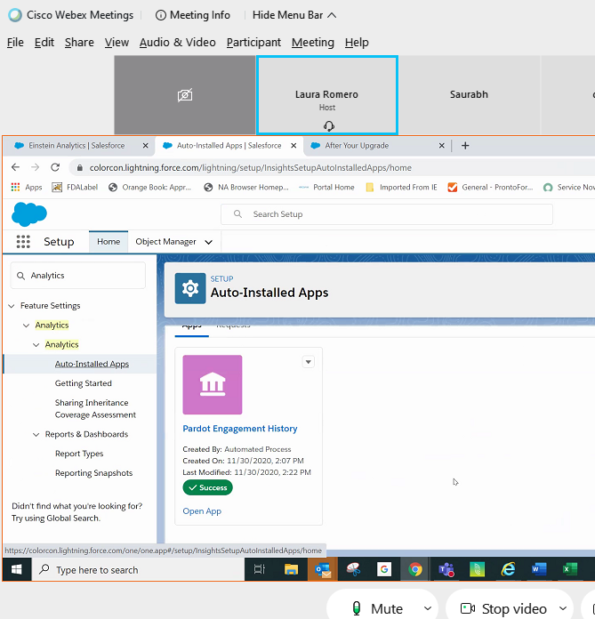

Here is the link to the Pardot Accelerator Library:

<https://www.salesforce.com/content/dam/web/en_us/www/documents/accelerators/accelerator-library.pdf>

# What was done for the end of 2020 app upgrade:

* Move custom datasets to the new app:
* Change SATest recipe to put its dataset in the new app
  + - We did: Data manager / Dataflow and recipe / recipe / SATest
      * Next time we want to try just moving the SATest dataset:
      * Data manager / Data / SATest / Edit on down arrow - change the app;
* Change Salesforce Account dataflow’s dataset by editing the dataset and pointing it to a new app (?) <https://www.simplysfdc.com/2018/09/einstein-analytics-how-to-rename.html#:~:text=When%20you%20edit%20the%20dataset,dataset%20to%20the%20new%20app.&text=To%20rename%20an%20app%2C%20simply,the%20title%20to%20change%20it>.
  + - Data manager / Data / Salesforce Account / Edit on down arrow - change the app;
    - 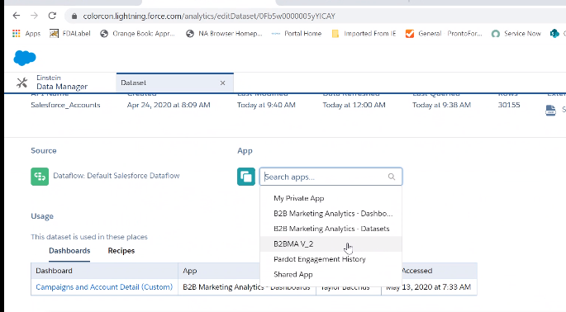
* Run SATest and salesforce account to update dataset
  + - Data manager / data flow and recipe / salesforce account / down arrow to run now
    - Data manager / monitor - see both running and successful
      * Moving a dataflow’s dataset - moves it
      * Pointing a recipe to a new app - creates a new one and leaves the old one not updating
* Move custom dashboards to the new app
  + Remove all dashboards in the new app that were previously copied
  + Move 3 dashboards to the new app (move is better than clone if you can do it)
    - Analytics studio / All items / choose old app
    - Edit each custom non-standard dashboard and click save and change app and note movement in version history
      * Campaign activity by prospect
      * Campaign activity by account
      * Asset Activity by Prospect
    - 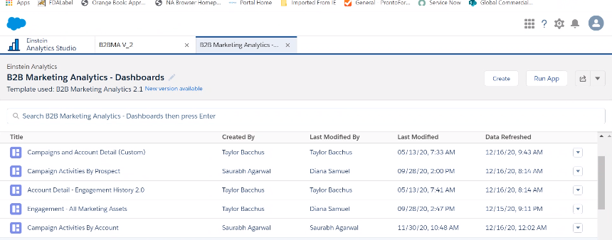
  + Use dashboard summary to ensure they are looking at the SATest dataset in the new app
    - They probably will need their code edited to point to the right app (Asset activity will be good because it does not use SATest)
      * Clone the 3 dashboards into your private app - very important
      * Create one new app over SATest to find the id
      * Edit the dashboard and hit ctrl e and see the dataset name and id
  + 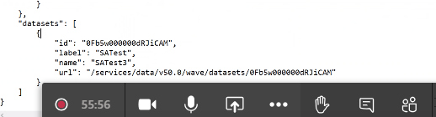
    - Then edit the real dashboards, ctrl / e, and replace the id, name and label everywhere in the code and then done and save and then verify all your widgets work. Remember the dataset with the label appears once at the end so be sure the label is correct.
  + Rename the engagement app to Engagement - All Marketing Assets
    - Edit the dashboard / save / change the name
  + Share the app
* Clean up now:
  + Unschedule all the dataflows and recipes we don’t use.
  + Move all lenses to private app
* Clean up early Jan:
  + Verify your dashboards are good
  + Delete all the dashboards not being used except those in the new app
  + Delete the dataflow for -dashboard and keep the V2 dataflow
  + Delete all the unnecessary recipes (or at least the ones that are just backups)
  + Delete lens
* Video of the process:
  + [Go to your video now](https://eastusr-notifyp.svc.ms/api/v2/tracking/method/Click?mi=ntntL0Iyi0K9J44KEVRtZw&tc=StreamVideo&cs=770949c7fb749c7391fdeb5bbb3b5946&ru=https%3a%2f%2fweb.microsoftstream.com%2fvideo%2f86b76826-4867-4a0b-b0ad-d8437a888eea) to publish, view, edit or share!

|  |  |  |
| --- | --- | --- |
|  | | |

# Colorcon Einstein Details

## Applications (5)

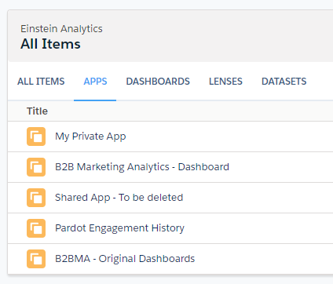

* Private
  + Each person has a private app for development and changes for just themselves. If they leave the company, this information is lost.
* B2B Marketing Analytics - Dashboard :
  + Latest upgrade - renamed from B2BMA-V2
  + It is created by installing a new B2BMA app and then we add 3 dashboards
  + This is the one that will be shared with reps
  + Dashboards:
    - Engagement - All Marketing Assets was created with the B2BMA app. The only thing changed was the name from Engagement to “Engagement - All Marketing Assets”
    - Asset Activity by Prospect
    - Campaign Activities by Account
    - Campaign Activities by Prospect
    - All others not used and deleted - they will be recreated with every upgrade
  + Lens:
    - None
  + Datasets
    - “B2B Marketing Analytics” app Dataflows
    - Recipe creates SATest here
    - Dataflow Default Salesforce Dataflow creates “Salesforce Accounts”
* Pardot Engagement History : Created by original B2BMA app creation and is updated automatically
  + Dashboards
    - 4 standard dashboards that are not used
  + Datasets
    - Pardot Engagement History - main dataset used by dashboards
    - Account Contact
    - Opportunity Contact Role
* B2BMA- Original dashboards
  + Original design - no longer used but kept as an example
  + Dashboards - original dashboards no longer used
  + Datasets -
    - We can delete all the datasets that last refreshed in 2020
    - There are some datasets that are still being refreshed but I think they will stop now because of the dataflow we deleted. We can delete them later.

## Dataflows (4) :

* B2BMA V_2 Marketing Analytics Dataflow - This flow creates the standard B2BMA datasets of Campaign Influence Models, Multi-Touch Attribution, ABM Events, ABM Opportunities, ABM Contacts, Prospect and Activity. These all go into B2B Marketing Analytics - Dashboard. *See the dataset by going to Data Manager’s Data Node and click on edit and see which app the datasets are being placed into and which dataflow created them.*
* Pardot Engagement History Dataflow - This was created with the original B2BMA and then updated periodically automatically. It creates the Pardot Engagement History (Pardot_Activity) that the recipe SATest points to. Both the B2BMA dataflows also use this dataset.
* Default Salesforce Dataflow - this was created by Taylor and simply creates a dataset of the Account SFDC connection called Salesforce Accounts and in the B2B Marketing Analytics - Dashboard app.

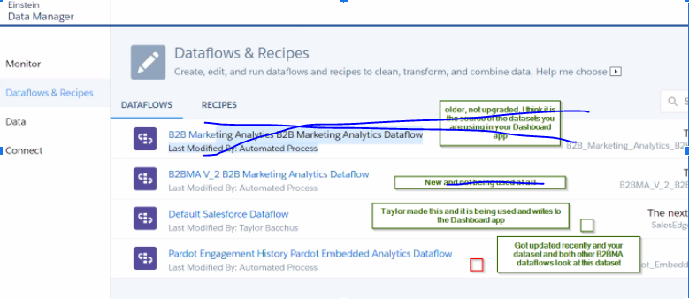

## Recipies

* SATest
  + Not test - very important
  + Built on top of
    - Salesforce Account dataset Taylor created (there is only one and it is in the “-Dashboard” app )
    - Pardot Engagement history dataset (there is only one and it is in pardot engagement history app )
  + Currently writing the database to the “- Dashboard” app
  + used in 3 dashboards
    - Asset Activity by Prospect
    - Campaign Activities by Account
    - Campaign Activities by Prospect

### Pictures of changes made:

## Default Salesforce Dataflow - completely new flow

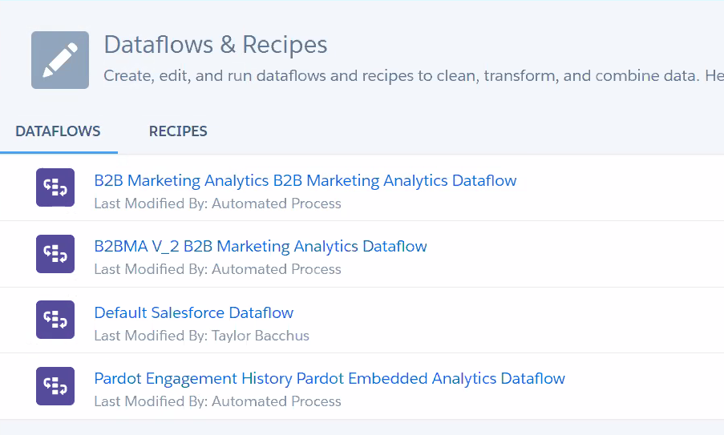

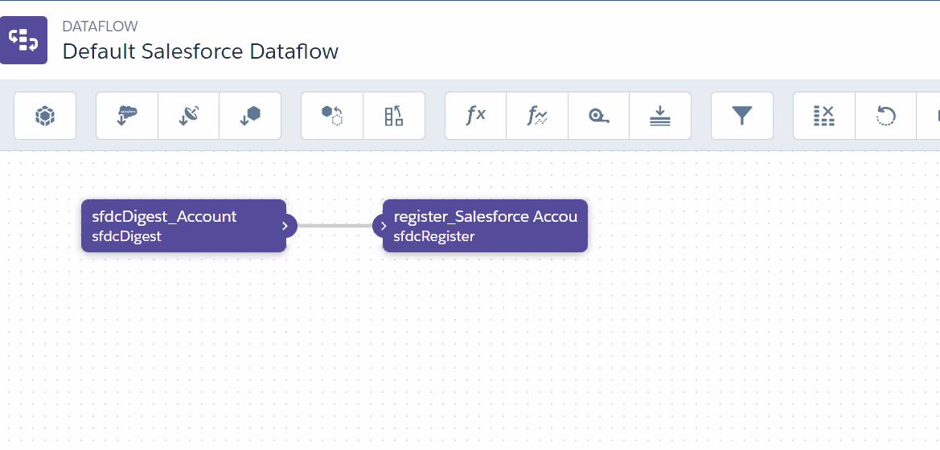

## SA Test Recipe

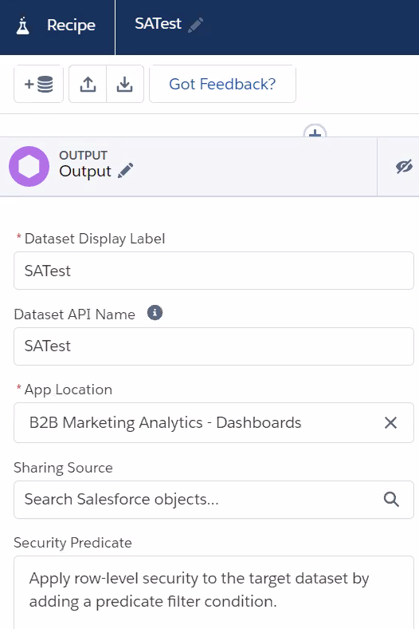

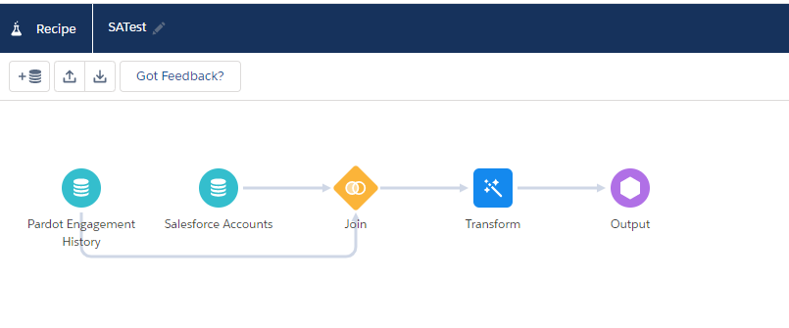

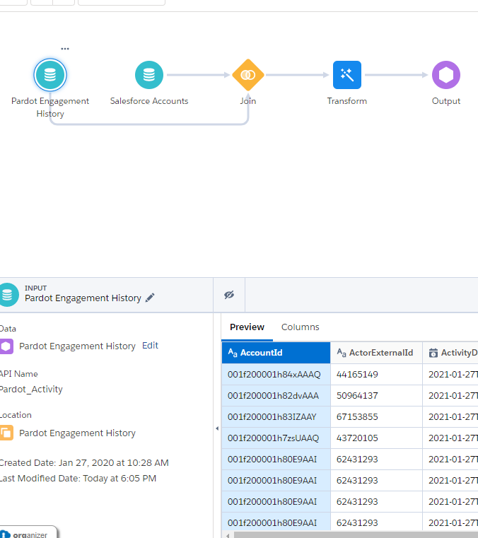

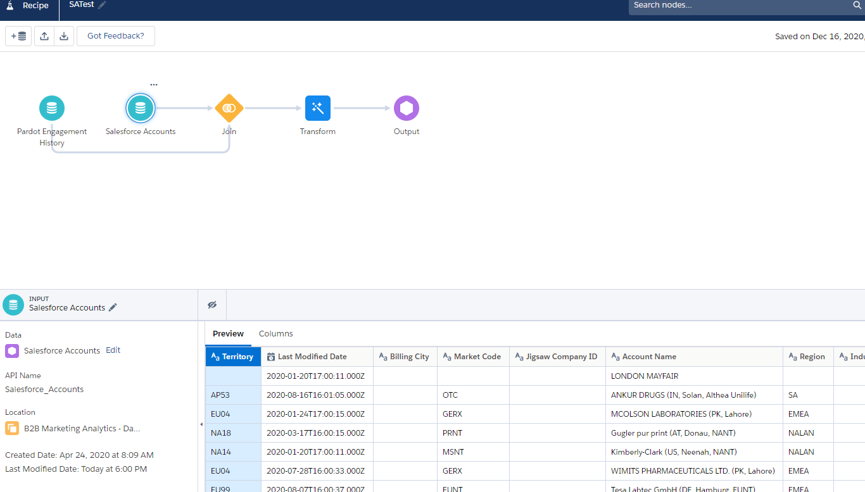

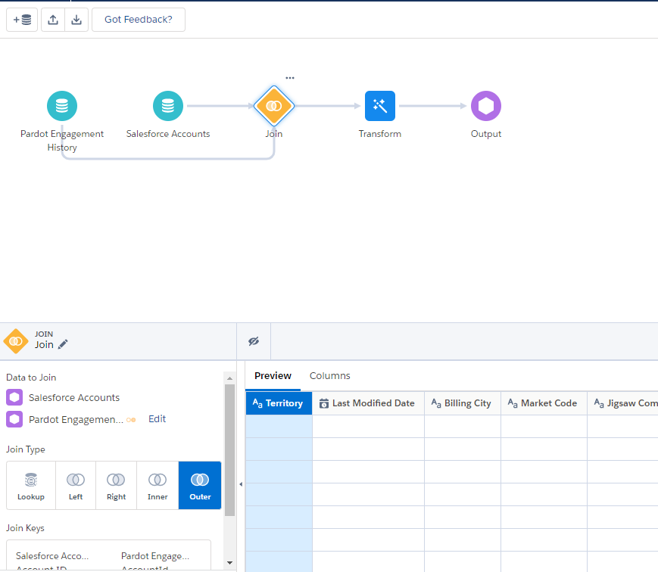

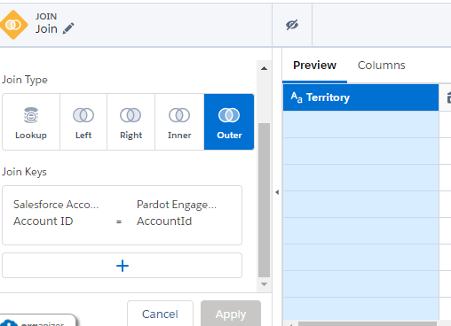

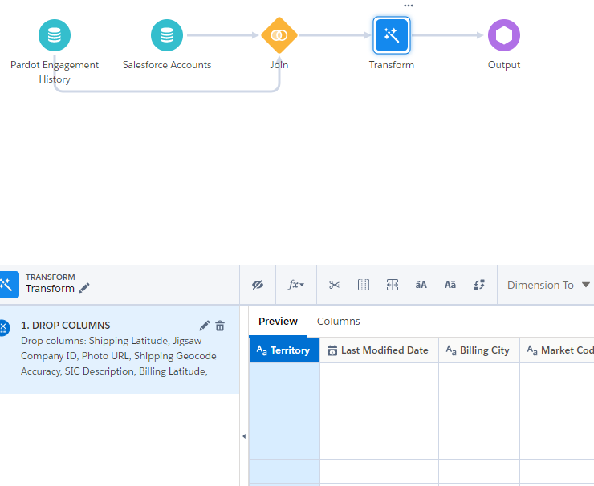

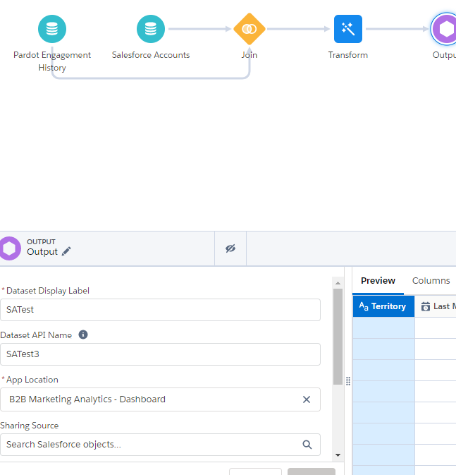

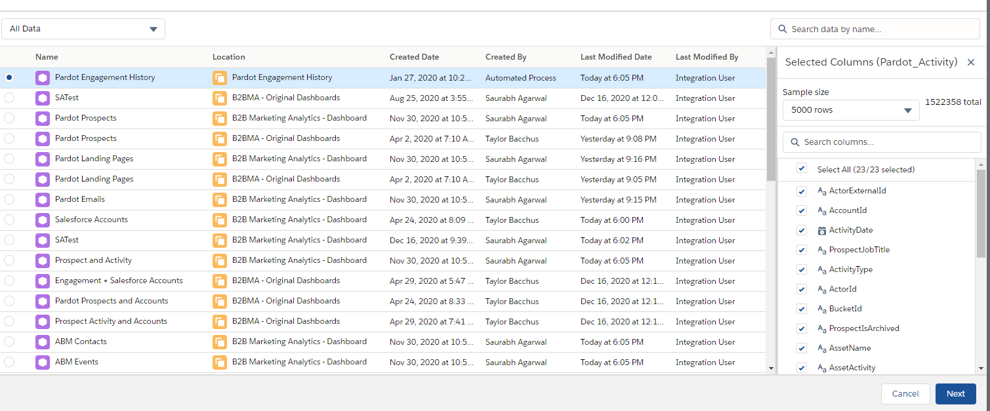

Share recording with viewers:

<https://nuageexperts.zoom.us/rec/share/a7h1ui-E1buoXu-qDJOs7d5Y-vfYQkO0b3tZ5bPAFTQlvseI6Zm5LJ4nULSjcacO.poV04hh6ehTgF-OR> Passcode: 8dsD@=F!